ADS 1 ASSIGNMENT REPORT

VISUALISATION

FULL NAME: Abigith Benson Benzigar

STUDENT ID: 22097433

DATA SOURCE: <https://data.worldbank.org/indicator/SP.POP.TOTL>

VISUALISATION PLOT 1(LINE PLOT)

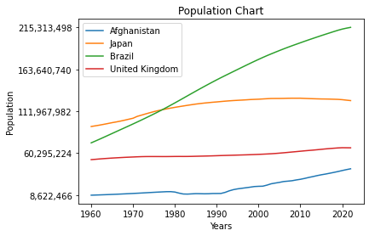

SUMMARY:

The population of the countries Afghanistan, Japan, Brazil, United Kingdom were plotted from the years 1960 to 2020 in the x axis under the label Years and the population is labelled in the y axis

Brazil has the most population increase throughout the years compared to other countries the population of United Kingdom remained saturated for all these years Japan’s population seem to be decreasing slightly after a small increase.

VISUALISATION PLOT 2(BAR CHART)

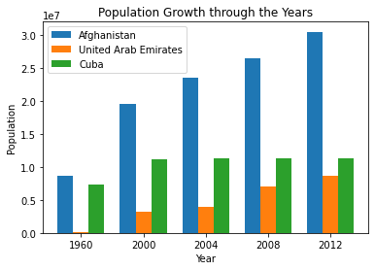

SUMMARY:

The population growth of the three countries Afghanistan, UAE, Cuba is compared on a bar chart, bar chart is good to compare few countries data on a sub data which can be compared side by side, the population of UAE seem to be small compared to Afghanistan, the population of Cuba is grown from 1960 to 2000 and seem to be saturated till the year 2012.

VISUALISATION PLOT 3(PIE CHART)

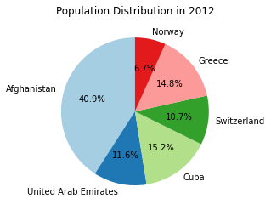

SUMMARY:

The pie chart is good when we want to compare population of multiple countries on a specific year, in this plot the population of Norway, Greece, Switzerland, Cuba, UAE, and Afghanistan are compared, Afghanistan have the largest population and Norway have the smallest population in the year 2012, rest of the countries have really similar population.